ECE Senior Project ~ The µBar

Final Project Report

Mr. Robert Benenyan

Mr. Cameron Chitsaz

Mr. Michael Hachache

Advisor – Dr. Rafi

California State Polytechnic University, Pomona

2013-2014 Academic Year

Table of Contents

1. Introduction
2. Team Member Tasks
3. Timeline of Project
4. Phase I – Fall Quarter 2013
5. Phase II – Winter Quarter 2014
6. Phase II – Spring Quarter 2014
7. Appendix A – Project Source Code

**Introduction**

The µBar is a microcontroller-based beverage dispenser designed to automate the beverage pouring experience. The idea came from inspiration of other cocktail-makers, however, the approach to this project differs in several different ways. First off, our team aimed at developing this project to be for all types of drinks (sodas, juices, water, etc.) so that all types of consumers will be able to use it. Secondly, cost was a very large factor playing into the design. Budgets of students are very low, thus not allowing for much funding to be put into the project. Initial budget was set around $250, reasonable enough for each student in the project.

Now let’s take a look at the technical side of the project. Taking a peek at the block diagram shown below you will see the initial design of the µBar. This includes a microcontroller at the center of the system, sensors for position and beverage, control as well as a user input module (touch LCD interface). Looking back at this design from our finished product you will notice there have been many drastic changes to the overall design, some for better functionality, but also some due to time constraints. As the three phases are discusses within the report you will have the opportunity to see the final result in comparison to the initial design.

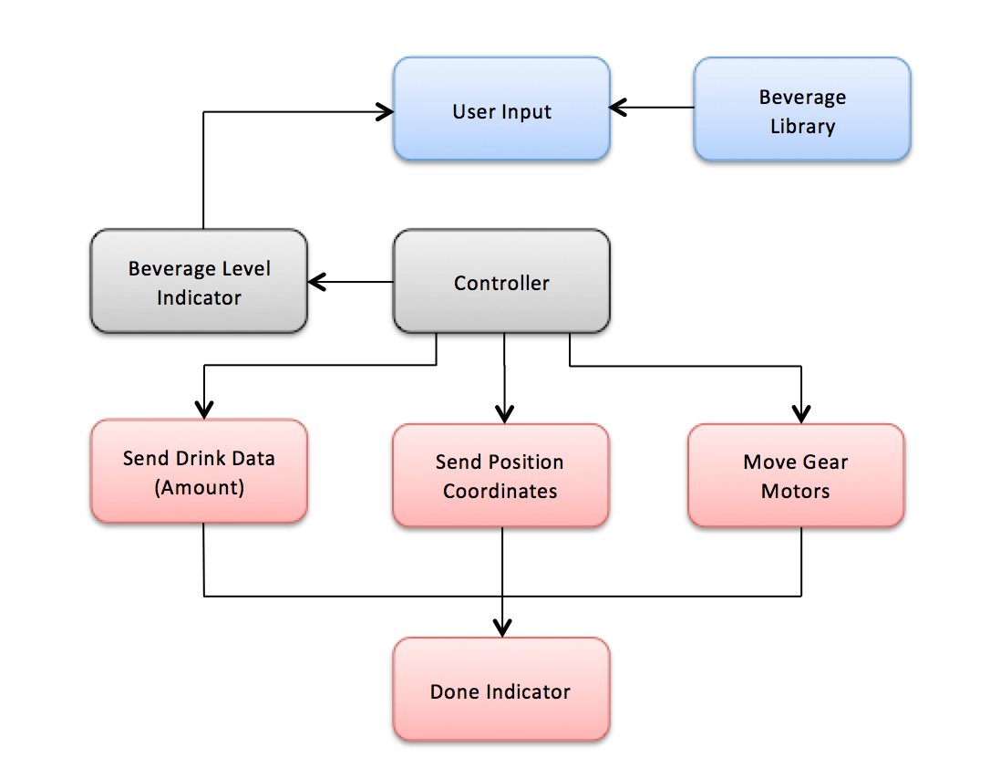

**Team Member Tasks**

Mr. Michael Hachache

Mr. Hachache’s main responsibility during the duration of this project is to design and implement a closed-loop motor control system. Using the chosen DC motor (Pololu 34:1 Metal Gearmotor 25Dx52L mm with 48 CPR Encoder) along with the encoder that is included, he will design an accurate motor control system (using PWM) for both speed and direction controlling. Additional sensors may be added to the system (infrared & phototransistors). The closed loop motor control is to be designed using a PIC18 and programmed in the C language.

Mr. Robert Benenyan

Mr. Benenyan’s tasks during the duration of this project will primarily consist of integrating a touch LCD with the PIC24 used in the design. He is to create a GUI for users to interface with by entering in the drink he or she desires. The GUI is to consist of several sets of menus, settings and allows users to even customize the type of beverage they like. Based off of the input the user gives, this PIC24 will communicate with the PIC18 controlling the motor to determine where the motor needs to move and pour the appropriate drinks. Again, the PIC24 will be programmed using C. ­

Mr. Cameron Chitsaz

Mr. Chitsaz will be the main lead of the frame design and implementation. Materials are to be obtained from a local hardware store and most likely will construct the frame out of ¾” whitewood. Once the basic frame is completed, integrating the following components is to be completed by the end of the third week of the Winter quarter: adding 5 liquid valves, dc motor with rack & pinion, shaft for dc motor. After all these materials are mounted, Mr. Chitsaz will assist Mr. Hachache with the closed-loop motor control as well as sensor set up and acquisition. His final task will be giving user wireless access to controlling the µBar through the development of an iOS application.

**Timeline of The µBar Project**

**Macintosh HD:Users:dotcom:Desktop:timeline final Sheet1.pdf**

**Phase I – Fall Quarter 2013**

Phase one of the µBar Project was considered the Research Phase. Our advisor, Dr. Rafi, pushed us to spend the entire portion of this quarter to designing the project and begin obtaining materials. The first task to be completed was the design of the chassis and frame, which was lead by Mr. Chitsaz. Secondly, Mr. Hachache took lead on the design for the motor control with feedback sensors (infrared & phototransistors) with a PIC18. Mr. Benenyan took responsibility for designing the user input module using a PIC24 and an LCD touch screen. As a team we discussed for endless hours on the final *look and feel* of our project before ordering materials.

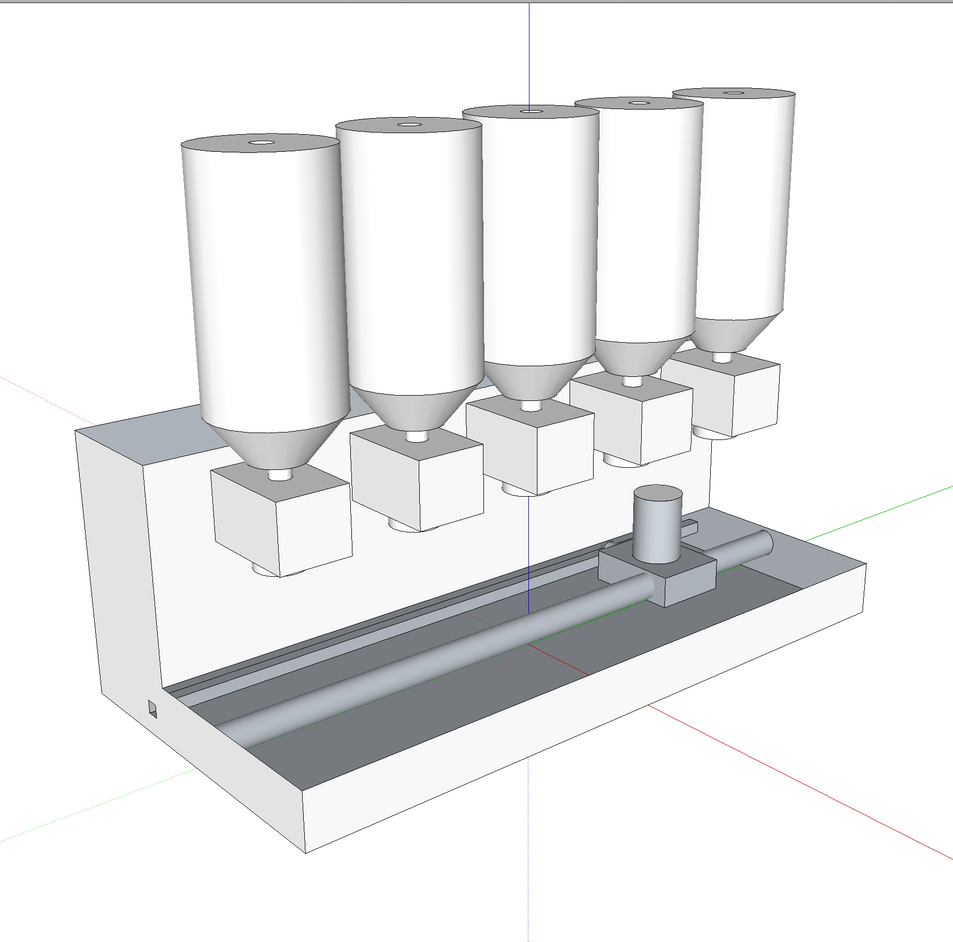 Once a week each of the team members met to discuss progress and push new improvements on our design. Over the quarter Mr. Chitsaz took the liberty to create a CAD drawing of our initial design, which can be found to the right. The design was based off of the normal soda fountains that can be found at any local fast food restaurant –several drink choices, a reservoir to hold the beverage, and a source of the cup holder. However, our design did not include any mechanical actuation that required users to manually push a *“pour”* button to actuate the drink. The place holder for the cup is sitting on some kind of metal based shaft (copper used in final design) with a rack and pinion set, which is facing the back end of the frame, to allow for the motor to translate its circular movement into horizontal motor movement. The tanks holding each beverage was designed with a volume of 1.5 gallons, enough for numerous drinks before refill. Also, the reason for this volume size was due to the frame support. Our frame design was based off wood, thus weight support cannot be more than hundred pounds or so. The wood chosen at the end of the quarter was ¾” thick whitewood. Several large sheets of this wood type was purchased from a local hardware store and cut to appropriate sizes. The end result was anticipated to be about 2.5’ tall, 1’ deep and 4’ in length.

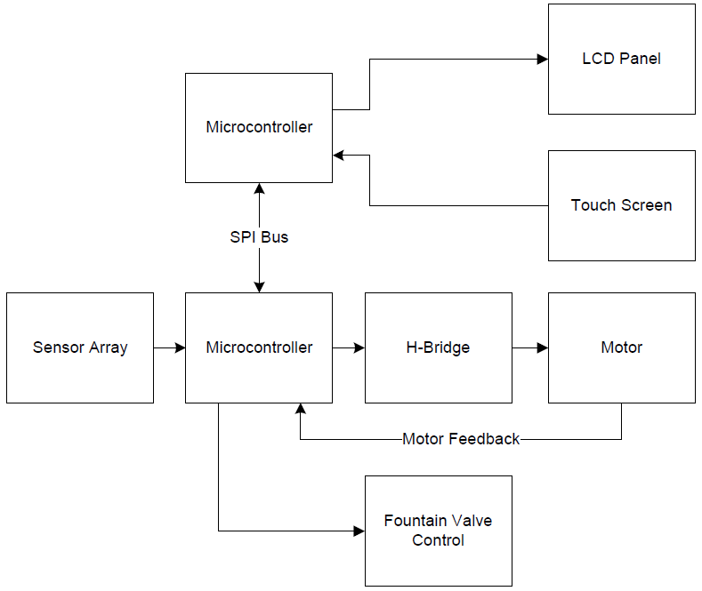 By the end of the Fall quarter of 2013 many changes had been made to the overall design. Looking at the block diagram shown to the right we already see the drastic changes to the overall design of the µBar project. The addition of another microcontroller was made; this would allow us to focus one microcontroller on the motor control and feedback sensors while having one microcontroller dedicated to LCD input control. This design choice was made by all three members after concluding the touch LCD interface with images take very much processing power and one PIC24 will not be able to handle driving both the LCD interface as well as the motor and feedback sensors. Also, the microcontroller that was going to drive the motor has now taken on the responsibility to actuate the valves for pouring of the beverages.

Now that the design had been tweaked and finalized, the next step was to make the order for the necessary materials. Below is a table showing the parts list we ordered by the end of the Fall quarter.

|  |
| --- |
| 29:1 Metal Gearmotor 37Dx52L mm |
| Rack and Pinion set - gear rack & pinion |
| 3/4" thickness Whitewood |
| Copper shafts (2) |
| PIC24 DIP Package |
| PIC18 DIP Package |
| 3.2" Touch LCD Module Part No. HX8352 (5) |
| Raspberry Pi Model B |
| PVC piping & valves |
| 50V Relays (2) |
| Electirc Solenoid 1/2" Valve |
| Misc. Chips/Wires/etc. |

**Phase II - Winter Quarter 2014**

The goal for second quarter of the senior project was ambitious from the start. We had agreed at the request of Dr. Rafi to have a very basic, but functional version of the project completed by the end of the second quarter. We ordered all necessary parts and equipment starting at the end of the first quarter up until the first few weeks of the second quarter. The features we wanted to cover during this quarter were: to have a platform that would house all of the valves and motor equipment, to have a way to move a cup from one side of the platform to the opposite side, and to have a LCD screen which displays information to the user. Since we have three members working on the project, we decided to split these tasks among the group. Robert Benenyan interfaced with the LCD and set up a controller for the valves, Cameron Chitsaz built the hardware and assisted in refining the motor controller, and Michael Hachache set up the motor controller and sensor grid. All members of the group assisted each other in miscellaneous activities besides their assigned tasks throughout the project.

As expected, each of us ran into problems during this project. But what’s an engineering project without facing obstacles? As a team we ran into numerous problems, however, after combining our intuitions together we were able to get past the many difficult obstacles. The first apparent problem that we faced was with the construction of the frame. Using ¾” whitewood for the frame was advantageous to us in terms of cost and ability to be easily modified, however, it proved not to be the strongest of materials. Mr. Chitsaz had to rebuild two parts of the frame (the upper portion with valve holes) due to large cracking in the wood. But once Mr. Chitsaz found the appropriate drill bit for the job (a spade drill bit), cracking was no longer an issue. The figures below show the frame construction when completed.

Hardware changes were also made with the motor control set up. Even before the initial start we had to change the motor driver we were using from a BA6886N to a Pololu MC33926. This was due to the fact that the BA6886N was unable to run off a PWM like we initially planned. The original motor control program had an issue stopping at the correct transistor due to a software error. After manipulating the code, everything worked as planned. Midway through the quarter, we changed our initial plan from using a PIC24 to a PIC18, due to the fact that all initial testing was done on the PIC18. We also dropped the operational voltage form 5 V to 3.3 V. This was because the motor driver only took 3 V inputs for FWD, REV, and EN pins. One of the biggest challenges faced this quarter occurred after creating the 12 V rail that the microbar would be running off of. The PIC18 was connected to a dedicated 5 V input, which caused many issues. Whenever a for-loop was ran in the code the PIC18 would shut off. Hours were spent trying to figure out what was happening, when all we needed was to connect everything to the 12 V rail. The PIC18 was fitted with a voltage regulator in order to step down to 3.3 V.

The original LCD that was ordered for the project turned out to be defective, and ended up wasting three weeks of troubleshooting until a replacement was purchased and shipped. Once arrived, the replacement LCD ran without any issues using the original driver written by Mr. Benenyan. The LCD is run using a PIC24. Because of the fact that over 20 pins must be used between the LCD and the microcontroller, Mr. Benenyan designed and manufactured a PCB breakout board for a 64pin PIC24, shown in Figure 1. The PIC24 was chosen because of its higher throughput, which allows for high-speed data transfer to the LCD. Once the interface between the microcontroller and the screen was completed, a simple graphical user interface was created so that uses can easily select what they wish to drink, shown in Figure 2. The touch screen driver for the LCD currently acknowledges that the user has touched the display, but cannot yet pinpoint exactly where on the screen the touch was made.

Initially, we made the decision to use N-Channel MOSFETs to control the state of the drink valves. A circuit board was hand made for this purpose, Figure 3. Because of the fact that all of the electronics in this project were designed to run on 3.3v, the voltage at the gate of the MOSFETs proved to be too low to turn the transistors on at the current carrying capacity that the valves required. A logic level shifter board, shown in Figure 4 was created to help with this, but this caused intermitted results from the board. We finally decided to switch to relays as the way to electronically open and close the drink valves. The relays work well when combined with the logic level shifter, however, it seems that the motor driving microcontroller resets itself after a valve is opened, and causes odd issues to occur at times. We believe that this is an issue with poor grounding and will work to fix it at the beginning of next quarter

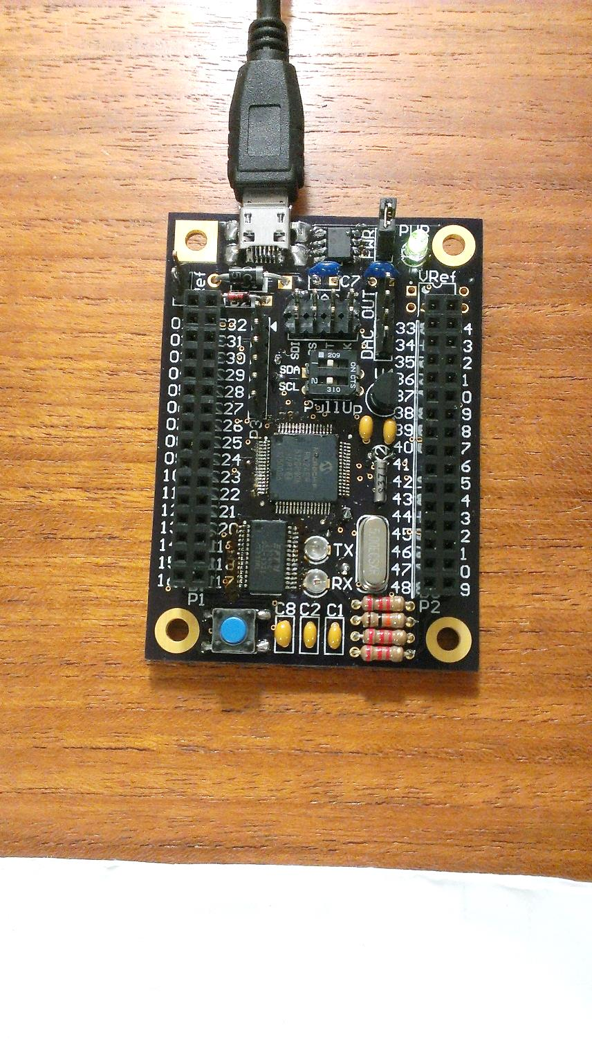 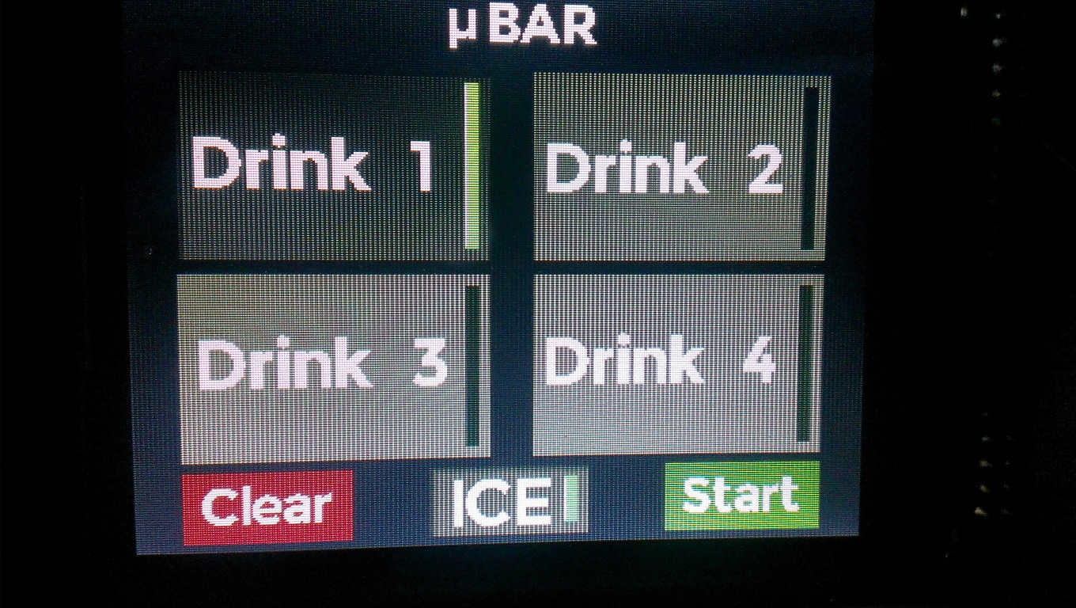

Figure 1: PIC24 Breakout Board Figure 2: Actual LCD Graphical User Interface

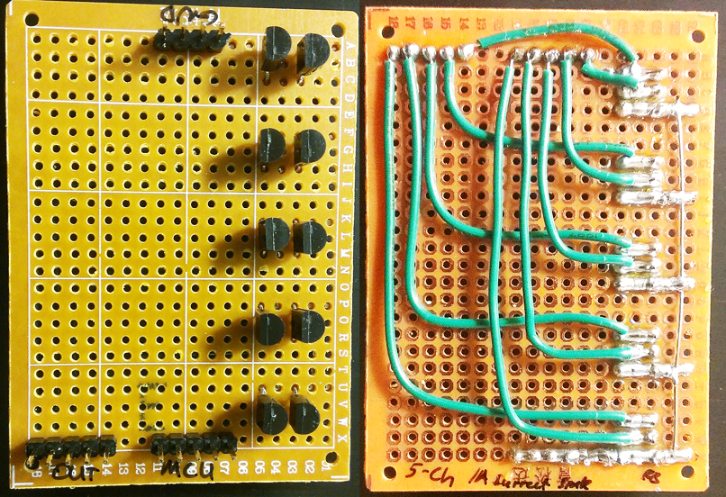 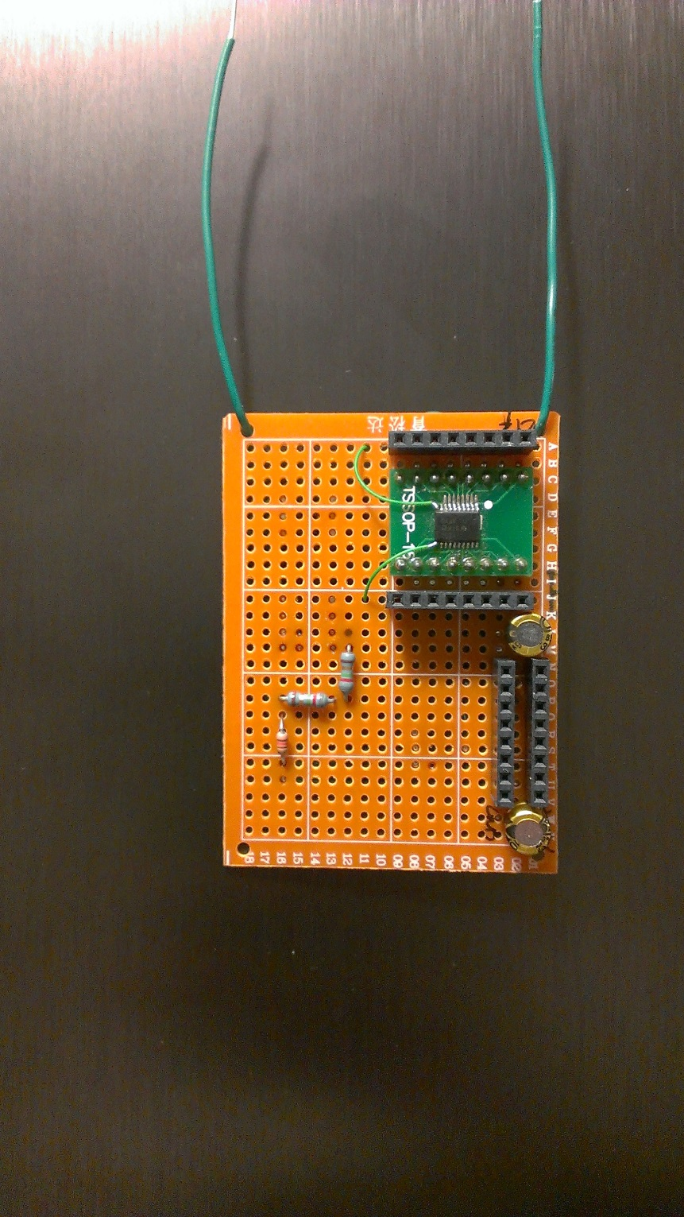

Figure 3: Five Channel MOSFET Board Figure 4: Logic Level Shifter

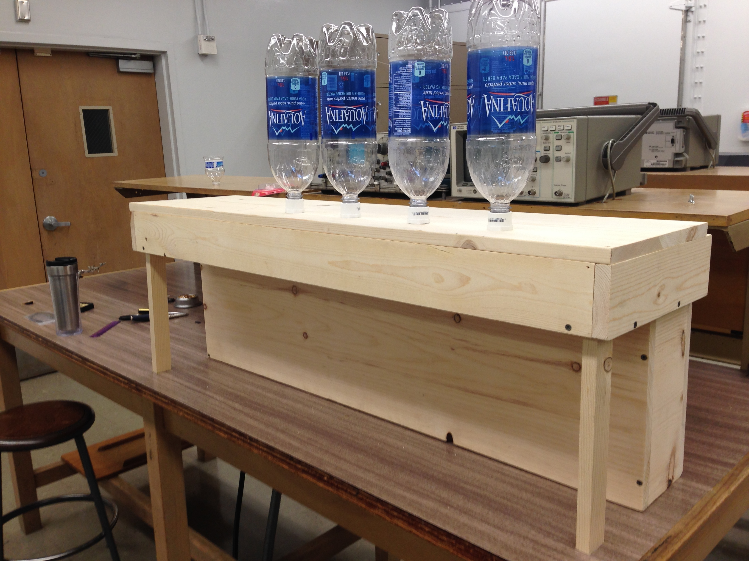

Figure 5: Upper portion of the µBar frame

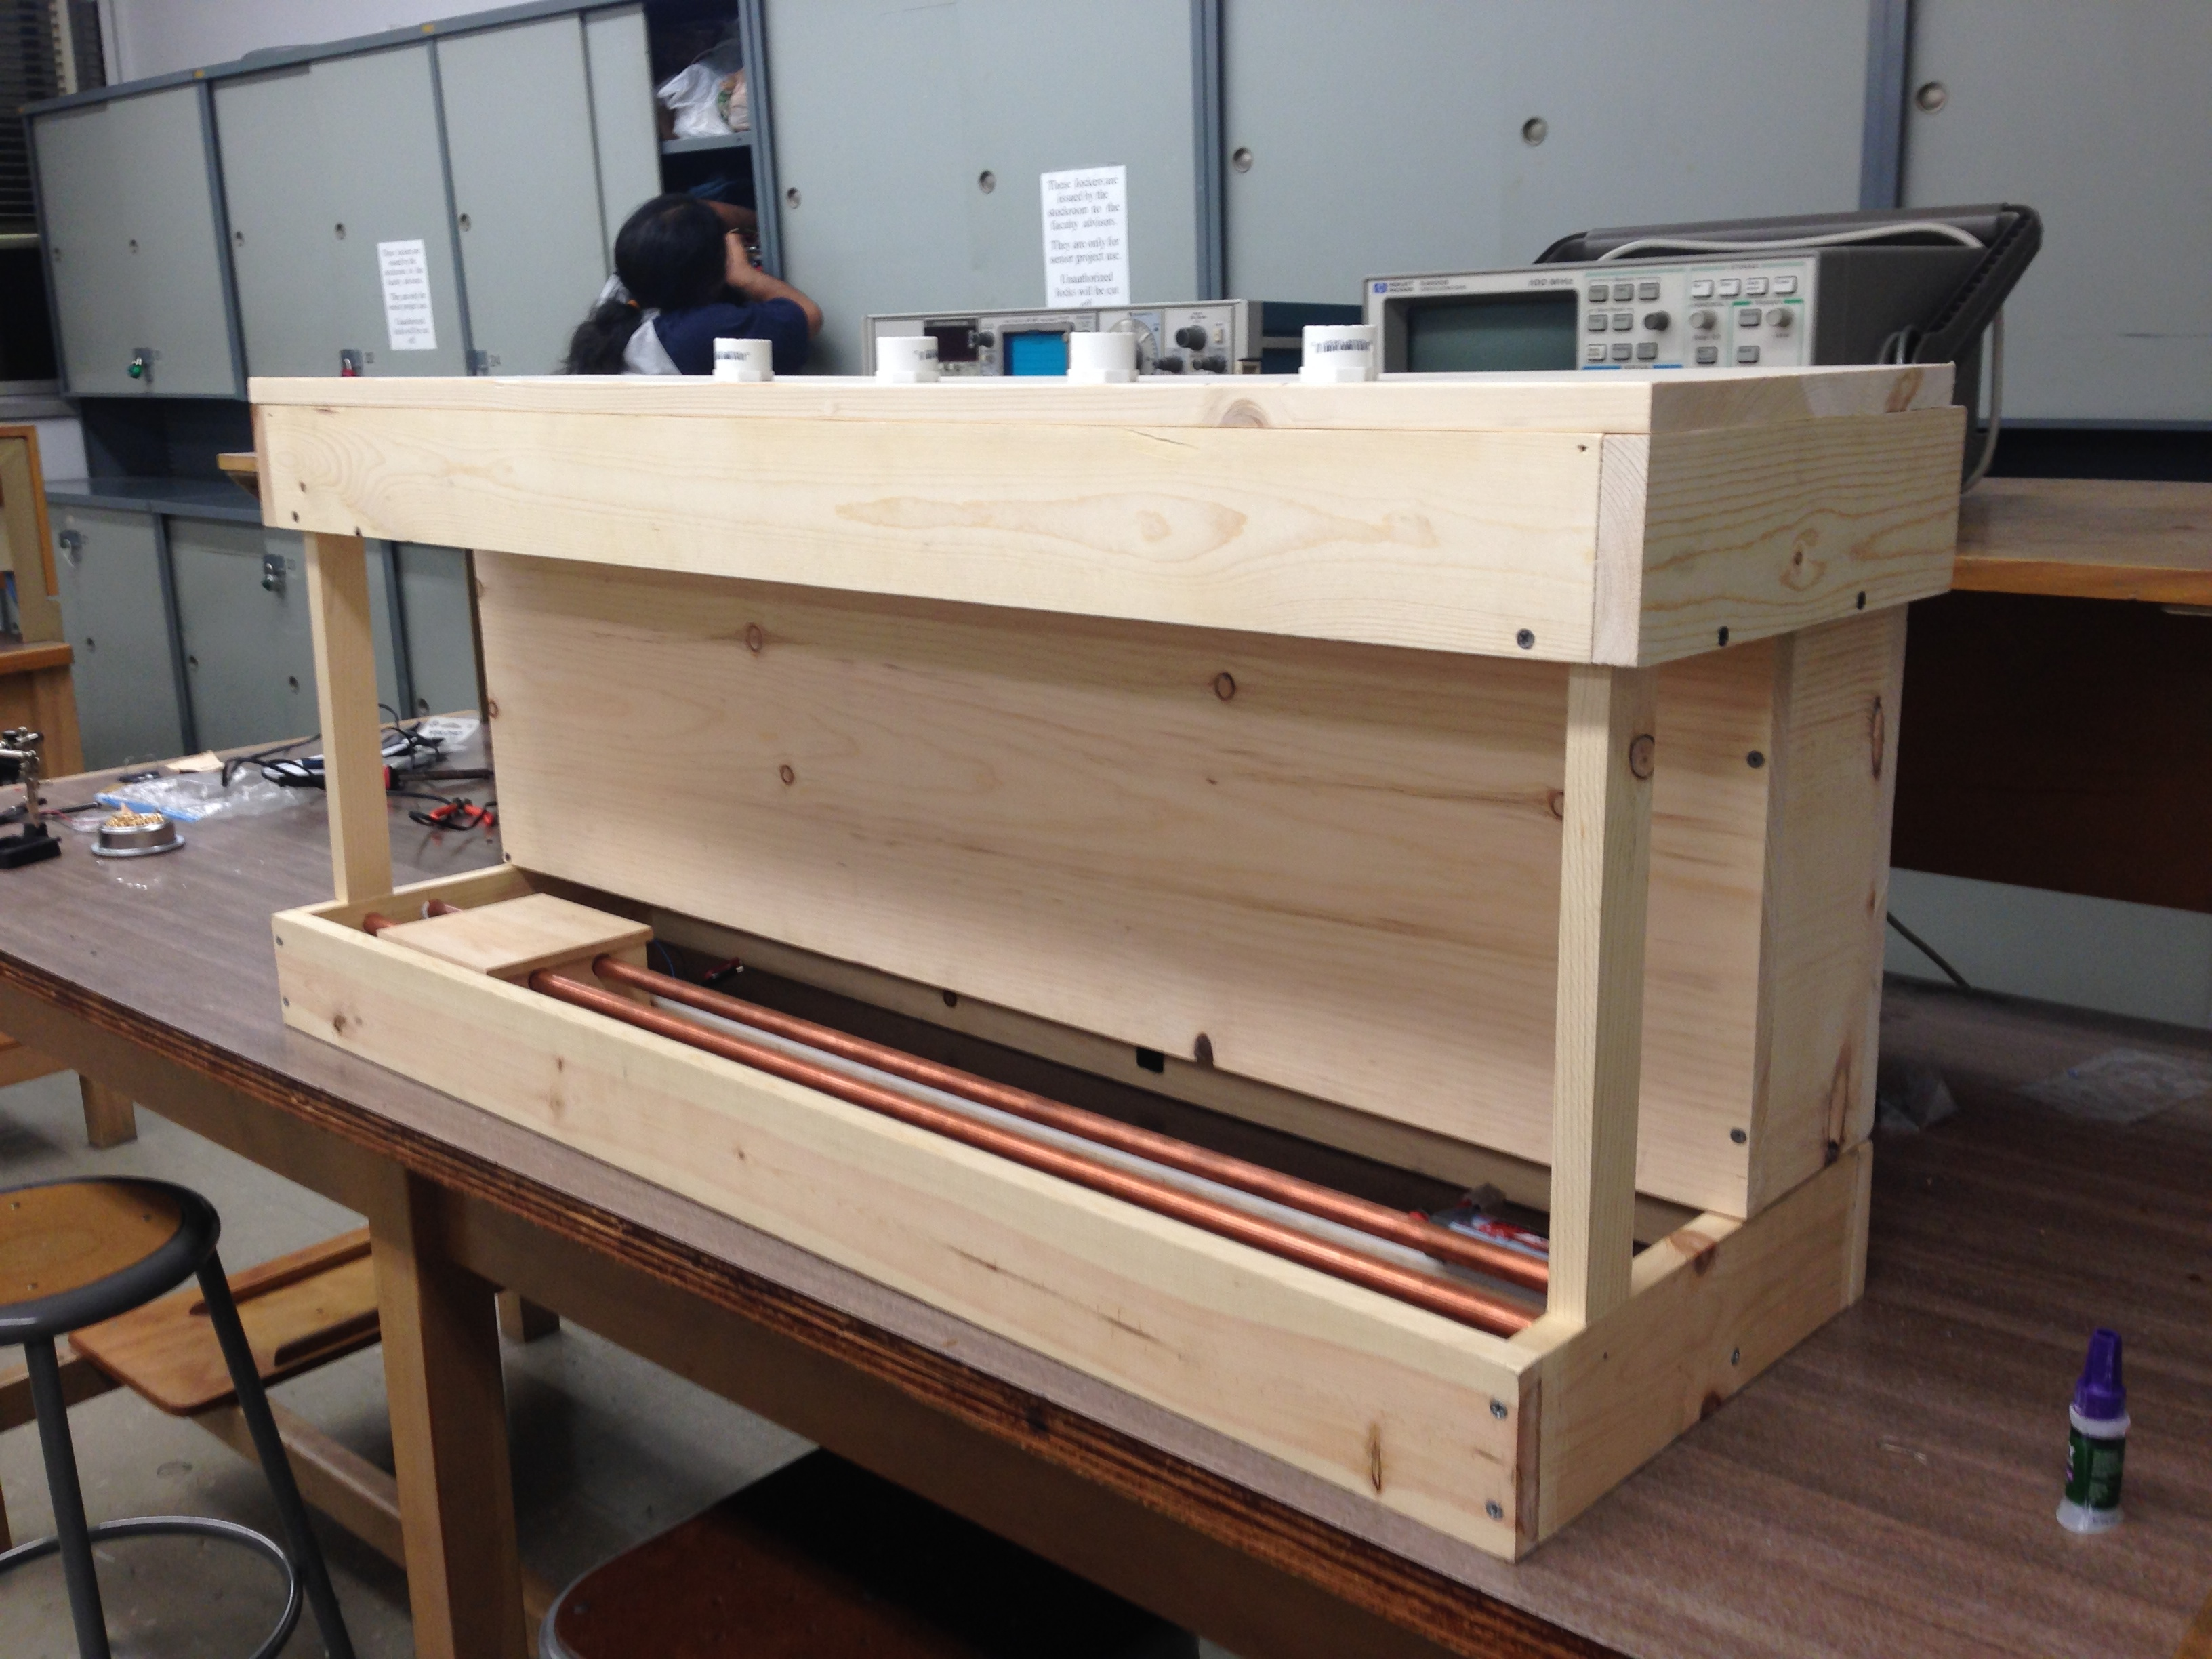

Figure 6: Integration of upper and lower portion

**Phase III - Spring Quarter 2014**

The Spring Quarter was very productive for our senior project. The valves that we used to pour the drinks were causing chaos in our electrical system. The first issue we began addressing at the start of the quarter was trying to find the best way to turn the valves on using the microcontroller. All of the logic for the motor driver was run on 3.3V. Mr. Benenyan created two MOSFET driver boards during the Winter Quarter to switch open the valves, however, due to the power spikes that the valves created when opening and closing, the gates of the MOSFETs burned out on several occasions. We decided to go ahead and use 15A relays instead of the MOSFETs since relays are more robust for tasks like these. The boards that the relays were mounted on came with optocouplers to help isolate some of the voltage spikes and power supply noose that the valves and the relays would produce so that the control circuitry would not be bothered. The problem with this was that the relay boards were designed to run on 5V, but all of the logic is based on 3.3V. To work around this, Mr. Benenyan engineered a 4 channel logic level shifter using operational amplifiers early in the Spring Quarter. Around the same time, Mr. Hachache ordered a 3A, 12VDC power supply among other needed supplies. The main reason the power supply was ordered was to reduce clutter and allow for us to stop using the lab’s bench power supplies. We also thought that this DC power supply would possibly have lower noise than some of the poorly maintained power supplies in the lab.

Initially, it seemed that the new power supply resolved the glitching issue, however there were still errors occurring regularly. Mr. Hachache completely stripped all of the wiring put together during the Winter quarter and rewired the entire chassis in a more organized and functional way as to remove unnecessary ground loops as well as remove redundant or inefficient cables. One of the improvements of this were newly played out power rails. Although having better power rails helped a great deal, the grounding problem from the valves persisted.

Mr. Benenyan and Mr. Hachache decided to completely isolate the power supply of the PIC18 from the rest of the relays, valves and motor. In order to do this, a secondary small power supply was used to power up only the logic. At this point, we had around a 90% success rate with most of the drink orders, although an occasional error would occur. The event that finally fixed this grounding problem was a spark of brilliance by Mr. Hachache who decided to put a delay between when the valve shuts itself closed, and the motor is told to move. It turns out that the sudden drop in voltage as well as the voltage spikes created by both the motor and the valves was too much when occurring simultaneously. By putting in a 1 second delay, the problem was fixed permanently.

During this time, Mr. Chitsaz was busy reassembling all of the wood framework for the project. Toward the end of the Winter quarter, after all of our testing, we notice that the frame had a few issues, such as having slightly misaligned shafts for the motor to travel on, causing it to fall of the track or get stuck. Because of this issue along with other necessary modifications, most of the woodwork was disassembled, corrected, then reassembled in order to perfect all of the aligning and sizing. Additionally, a coat of stain was applied to the entire project, giving it a clean and finished look. Another feature worth mentioning was how the infrared sensors that are used to track the position of the drink were built into the frame, removing extra clutter and reducing the number of loose wires in the vicinity of the motor.

At the same time, Mr. Benenyan, who was in charge of the Graphical User Interface and the LCD driver last quarter, did more work and refining on the LCD aspect of this project. As a team, we decided it would be a nice feature to display LCDs on top of each drink showing the logo of what drink was being dispensed at that particular valve. This provided a challenge since each LCD requires 36 data and control wires. Mr. Benenyan had designed a PIC24 breakout board last quarter to drive the single LCD that was used to make orders. This quarter, he designed two additional PCBs. The first of these boards plugs into the PIC24 board made last quarter; the second plugs behind each LCD. By implementing this design, one 40-pin ribbon would need to be connected to the PIC24 board, and n-number of LCDs can be daisy chained using the second board. This eliminates individual wires that could come disconnected accidentally and cause horrendous problems trying to debug. The setup of the LCDs is shown in Figure 1.

During the beginning of the Spring quarter, the programming for the LCD controller was heavily modified. The ability to display bitmaps was important if we were to show logos of companies like Coke and Pepsi on multiple LCDs. A Python script was written to convert any picture into a bitmap array. The script also formatted the array such that it would make it easy to implement in the C30 compiler for the PIC24 since 320*240 integers need to be stored for a single bitmap. The remainder of time not spent on debugging other systems was spent on designing, checking and assembling the two PCB designs, totaling in 7 custom assembled boards, and three unique designs. Once assembly was done, new programming needed to be implemented to drive multiple LCDs, which proved to be one of the most challenging steps of this entire project. Fortunately, no fatal mistakes were made during the PCB design stage, allowing us the control of each individual display.

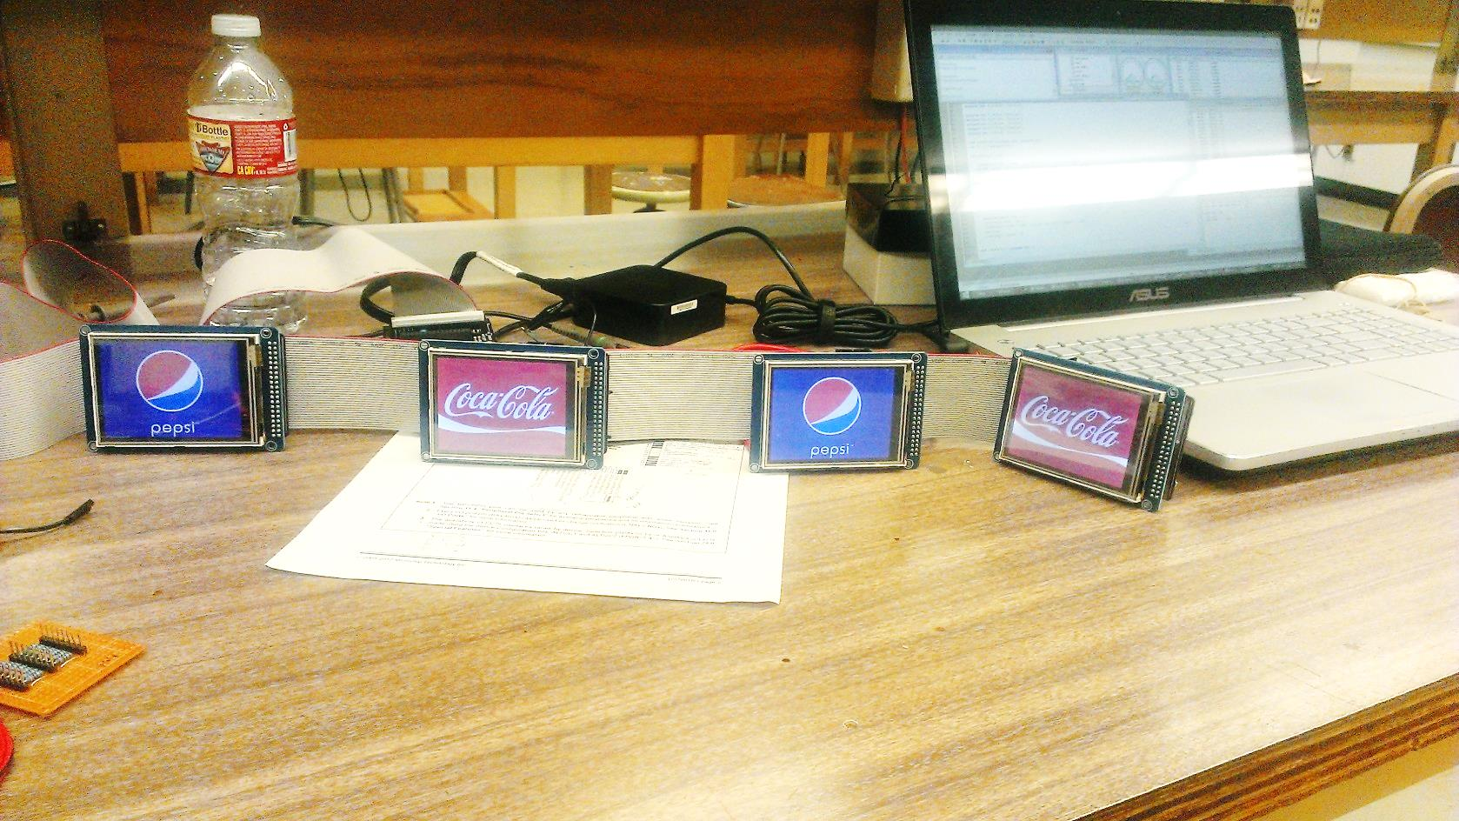

Figure 1: LCD Daisy Chaining

Near the same time the PCBs were being designed and put together, Mr. Chitsaz began making a lot of progress designing the iOS iPhone app for this project. The app is designed to communicate to a server hosted by a Raspberry Pi on a local WiFi network. The phone will connect to the server over a local wireless router, and send the drink order. Once the server receives the order, the onboard GPIO of the Raspberry PI pins will send the command for one or multiple drinks to be requested to the motor controller microcontroller. Once the motor controller receives the order, an acknowledge pin is toggled high and the drink making process begins. A similar parallel communication system would be used between the Raspberry Pi and the PIC18 to make sense of an order request. Initially, there were problems when ordering more than one drink with the app, but it did not take long to iron that issue out. The user interface of the app can be seen in Figure 2.

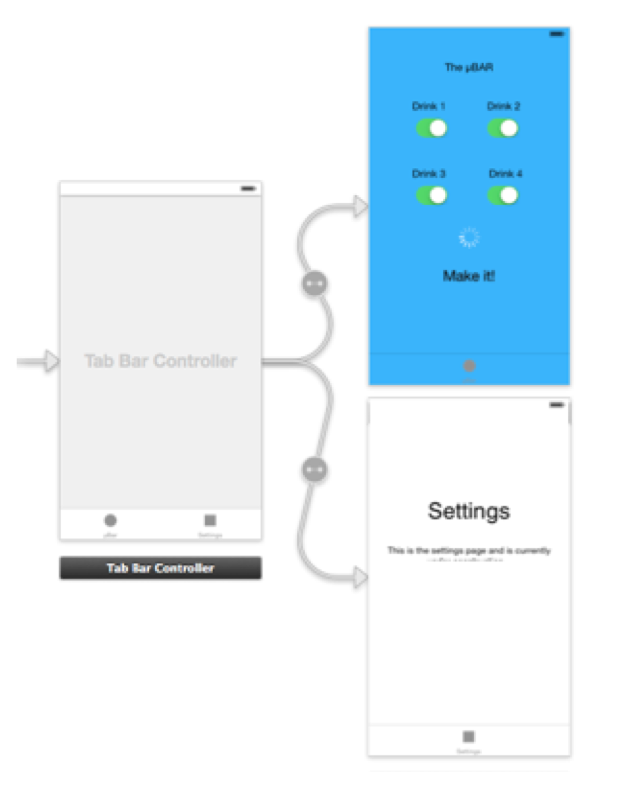

Figure 2

As promised, we presented our demonstration on Tuesday of Week 9. The demonstration showed one drink being ordered, and the multiple drinks being ordered at one time. The final assembled senior project can be seen in Figure 3. All components of the project function exactly as planned during the demonstration thanks to the great planning and advisement of Dr. Rafi as well as the teamwork and persistence among all team members. We thank you for accepting our project and taking on the role of our senior project adviser!

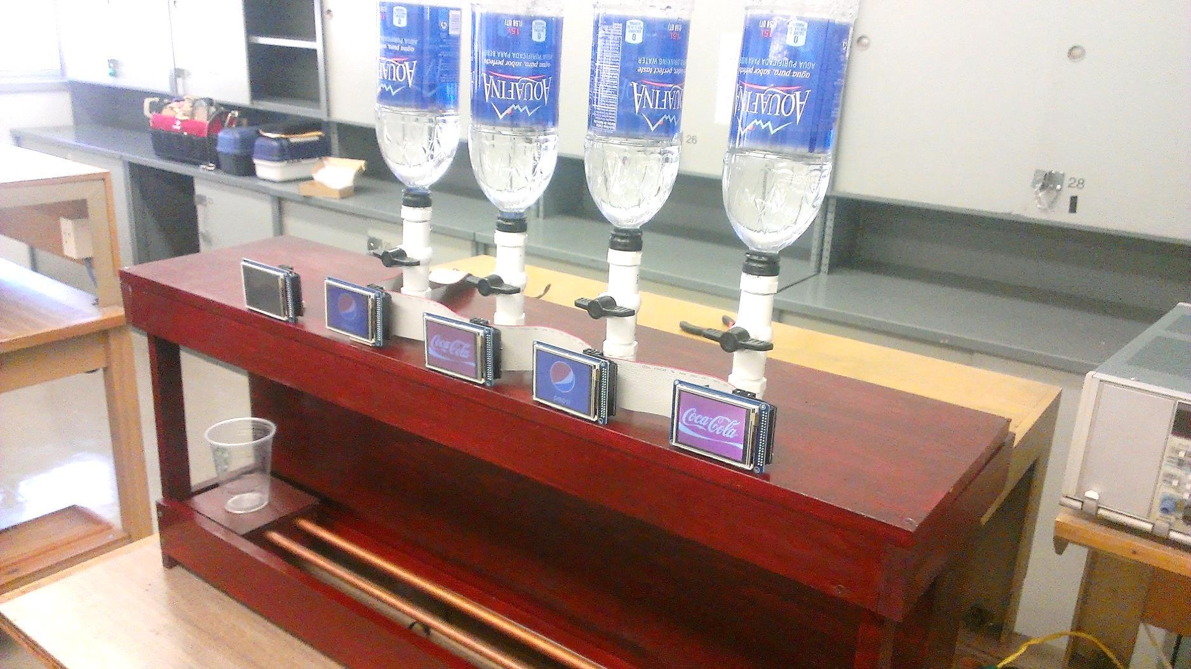

Figure 3: Completed Senior Project

**Project Source Code**

**Position/PWM Motor Control Code**

#include <p18f4321.h>

#include <stdio.h>

#pragma config OSC = INTIO2

#pragma config WDT = OFF

#pragma config LVP = OFF

#pragma config BOR = OFF

#pragma interrupt chk_isr

#define RIGHT PORTBbits.RB5 //pin 34 (7 top right)

#define LEFT PORTBbits.RB4 //pin 35 (6 top right)

//Phototransistors

#define pos1 PORTDbits.RD0 //pin 19

#define pos2 PORTDbits.RD1 //pin 20

#define pos3 PORTDbits.RD2 //pin 21

#define pos4 PORTDbits.RD3 //pin 22

#define pos0 PORTDbits.RD7 //pin 10

//Order Buttons

#define start PORTAbits.RA0 //start

#define ice PORTAbits.RA1 //ice

#define drink1 PORTAbits.RA2 //drink1

#define drink2 PORTAbits.RA3 //drink2

#define drink3 PORTAbits.RA4 //drink3

#define drink4 PORTAbits.RA5 //drink4

//Output for valves

#define cupDispensor PORTBbits.RB0 //cup dispensor

#define iceDispensor PORTBbits.RB1 //ice dispensor

#define valve1 PORTBbits.RB2 //valve 1

#define valve2 PORTBbits.RB3 //valve 2

#define valve3 PORTBbits.RB6 //valve 3

#define valve4 PORTBbits.RB7 //valve 4

//reset all the latches on the LCD

#define LCDreset PORTEbits.RE0

//Percent value of duty cycle. CCPR1L = 50 will result in 50% duty cycle

#define PWM CCPR1L //RC2 pin 17

void init(void);

void chk_sir(void);

void setOrder(char);

int readOrder(void);

void openValve(char);

void closeValve(char);

void goHome(void);

void goToDrink(int, int);

void wait(void);

void pourDrink(int, int);

//Global Variables

int currPos = 0;

int drinkOrder[5] = {6,6,6,6,6}; //Array holds the position number for the selected drink.

int i, j, drink, timer = 0, timer2 = 0, counter = 0;

int k;

int drinkNumber = 0, totalNumberOfDrinks = 0;

//Interrupt service routine for Timer2

void chk_isr()

{

PIR1bits.TMR2IF = 0; //clear Timer2 flag

}

#pragma code My_HiPriority_int = 0x08

void My_HiPrio_int()

{ _asm

GOTO chk_isr

_endasm

}

#pragma code

//Initializer

void init()

{ //Initialize Clock

OSCCON = 0x70;

//Initialize I/O

TRISC = 0;

TRISD = 0xFF;

TRISA = 0xBF;

TRISB = 0x00;

TRISE = 0x06;

//Initialize ADC

ADCON0 = 0x00; //ADC off

ADCON1 = 0x0F;

//Initialize Interrupts

INTCONbits.GIE = 1;

INTCONbits.PEIE = 1;

INTCONbits.INT0IE = 1;

INTCONbits.INT0IF = 0;

INTCON2 = 0xE0;

//Initialze PWM and Timer2

CCP1CON = 0x0C;

PR2 = 0x63;

T2CONbits.TMR2ON = 1;

PIE1bits.CCP1IE = 1;

PIE1bits.TMR2IE = 1;

CCP1CONbits.DC1B = 0x00;

CCPR1L = 0x12;

valve1 = 1;

valve2 = 1;

valve3 = 1;

valve4 = 1;

PWM = 90;

RIGHT = 0;

LEFT = 0;

LCDreset = 0;

k = 0;

}

void goHome()

{ while(pos0 != 1)

{

LEFT = 1;

}

currPos = 0;

LEFT = 0;

RIGHT = 0;

}

void goToDrink(int drink, int NumberOfDrinks)

{ if(drink == 1)

{

while(pos1 != 1)

{

if(currPos < 1)

{

RIGHT = 1;

}

else

{

LEFT = 1;

}

}

currPos = 1;

}

if(drink == 2)

{

while(pos2 != 1)

{

if(currPos < 2)

{

RIGHT = 1;

}

else

{

LEFT = 1;

}

}

currPos = 2;

}

if(drink == 3)

{

while(pos3 != 1)

{

if(currPos < 3)

{

RIGHT = 1;

}

else

{

LEFT = 1;

}

}

currPos = 3;

}

if(drink == 4)

{

while(pos4 != 1)

{

if(currPos < 4)

{

RIGHT = 1;

}

else

{

LEFT = 1;

}

}

currPos = 4;

}

RIGHT = 0;

LEFT = 0;

pourDrink(NumberOfDrinks, currPos);

}

void pourDrink(int delay, int position)

{

RIGHT = 0;

LEFT = 0;

timer = 0;

if(position == 1)

{

valve1 = 0;

}

if(position == 2)

{

valve2 = 0;

}

if(position == 3)

{

valve3 = 0;

}

if(position == 4)

{

valve4 = 0;

}

while(timer < 10000/delay)

{

while(timer2 < 250)

{

timer2 = timer2 + 1;

}

timer2 = 0;

timer = timer + 1;

}

valve1 = 1;

valve2 = 1;

valve3 = 1;

valve4 = 1;

}

void wait()

{

RIGHT = 0;

LEFT = 0;

timer = 0;

while(timer < 500)

{

while(timer2 < 250)

{

timer2 = timer2 + 1;

}

timer2 = 0;

timer = timer + 1;

}

}

int readOrder()

{

if(drink4 == 1)

{

drinkOrder[counter] = 4;

counter = counter + 1;

}

if(drink3 == 1)

{

drinkOrder[counter] = 3;

counter = counter + 1;

}

if (drink2 == 1)

{

drinkOrder[counter] = 2;

counter = counter + 1;

}

if(drink1 == 1)

{

drinkOrder[counter] = 1;

counter = counter + 1;

}

return counter;

}

void main ()

{

init();

while(1) {

goHome();

while(start == 0){}

counter = 0;

totalNumberOfDrinks = readOrder();

LCDreset = 1;

k = 0;

while(drinkOrder[k] != 6)

{

goToDrink(drinkOrder[k],totalNumberOfDrinks);

k++;

}

goHome();

LCDreset = 0;

}

}

**Example Code for LCD Drive Module**

//adding a button for the LCD Graphical User Interface

void addButton (unsigned int x, unsigned y, unsigned int colorOff, unsigned int colorOn, unsigned char state, unsigned char bW, unsigned char bH)

{

if (state == 0x00)

{ //button is NOT selected

drawRect(x,y,bW,bH,colorOff); //draw rectangle

//drawRect(bW-10+x, y+5, 5, bH-10, setColor(0,10,3));

//indicator 0,8,3 -> off

//drawRect(bW-10+x, y+6, 1, bH-12, setColor(3,3,3));

//indicator highlight

}

else if (state == 0xAA)

{

drawRect(x,y,bW,bH,colorOff);

}

else if (state == 0xA0)

{

drawRect(x,y,bW,bH,colorOn);

drawRect(x, y, bW, 1, border0); //border top

drawRect(x, y, 1, bH, border0); //border left edge

}

else

{

//button IS selected

drawRect(x,y,bW,bH,colorOn); //main shape

drawRect(x, y, bW, 1, border0); //border top

drawRect(x, y, 1, bH, border0); //border left edge

drawRect(x+2, y+1, bW-2, 1, border1); //border top

drawRect(x+2, y+1, 1, bH-1, border1); //border left edge

drawRect(x+2, y+2, bW-2, 0, border2); //border top

drawRect(x+2, y+2, 0, bH-2, border2); //border left edge

drawRect(bW-10+x, y+5, 5, bH-10, setColor(0,100,20));

//indicator 0,8,3 -> off

drawRect(bW-10+x, y+6, 1, bH-12, setColor(90,100,85));

//indicator highlight

}

}

void fillPepsi ()

{

setLocation (0,0,SH,SW);

unsigned int limit = SS >> 1;

unsigned int i = 0;

for (i = 0; i < limit; i++)

{

sendData(rawColor(coke_RED0[i],coke_GREEN0[i],coke_BLUE0[i]));

}

for (i = 0; i < limit; i++)

{

sendData(rawColor(coke_RED1[i],coke_GREEN1[i],coke_BLUE1[i]));

}

}

void fillCoke ()

{

setLocation (0,0,SH,SW);

unsigned int limit = SS >> 1;

unsigned int i = 0;

for (i = 0; i < limit; i++)

{

sendData(rawColor(coke_RED0[i],coke_GREEN0[i],coke_BLUE0[i]));

}

for (i = 0; i < limit; i++)

{

sendData(rawColor(coke_RED1[i],coke_GREEN1[i],coke_BLUE1[i]));

}

}

int main ()

{

initIO();

initLCD();

initSPI();

screenSel = 0;

fillPepsi();

screenSel = 1;

fillCoke();

screenSel = 2;

fillPepsi();

screenSel = 3;

fillCoke();

while (1);

return 0;

}

**iPhone Application Main Code**

#import "COMFirstViewController.h"

#import <UIKit/UIKit.h>

#import <Foundation/Foundation.h>

#import <objc/runtime.h>

#import "NeXTGarageClient.h"

#import "COMAppDelegate.h"

#import "AsyncSocket.h"

#import "NextGarageApp.h"

@interface COMFirstViewController ()

@property (weak, nonatomic) IBOutlet UISwitch *drank1switch;

@property (weak, nonatomic) IBOutlet UISwitch *drank2switch;

@property (weak, nonatomic) IBOutlet UISwitch *drank3switch;

@property (weak, nonatomic) IBOutlet UISwitch *drank4switch;

@property (weak, nonatomic) IBOutlet UIActivityIndicatorView *spinWheel;

@property (weak, nonatomic) IBOutlet UIButton *makeButton;

@end

@implementation COMFirstViewController

/*--------- Actions to perform when makeButton is pressed -----------*/

- (IBAction)makeDrink:(id)sender {

if (![self drank1switch].isOn && ![self drank2switch].isOn && ![self drank3switch].isOn && ![self drank4switch].isOn)

{

NSLog(@"None of the switches are on!");

}

else

{

NextGarageApp * app = (NextGarageApp *) [UIApplication sharedApplication];

app.connection = [[NeXTGarageClient alloc] init:@"192.168.2.2" port:2018];

[app.connection connect];

[self performSelectorInBackground:@selector(startAnimation) withObject:nil];

uint8_t *data = malloc(1);

*data = 0;

if ([self drank1switch].isOn)

{

*data += 1;

}

if ([self drank2switch].isOn)

{

*data+=5;

}

if ([self drank3switch].isOn)

{

*data+=9;

}

if ([self drank4switch].isOn)

{

*data+=17;

}

[app.connection sendMessage:@"makeDrink" d:data];

free(data);

[[self drank1switch] setOn:NO animated:YES];

[[self drank2switch] setOn:NO animated:YES];

[[self drank3switch] setOn:NO animated:YES];

[[self drank4switch] setOn:NO animated:YES];

sleep(5);

[self stopAnimation];

[app.connection disconnect];

app.connection = nil;

}

}

- (void)didReceiveMemoryWarning

{

[super didReceiveMemoryWarning];

// Dispose of any resources that can be recreated.

}

/* ------------- To Do when page is opened --------------------*/

- (void)viewDidLoad

{

[super viewDidLoad];

[[self drank1switch] setOn:NO animated:YES];

[[self drank2switch] setOn:NO animated:YES];

[[self drank3switch] setOn:NO animated:YES];

[[self drank4switch] setOn:NO animated:YES];

[self spinWheel].hidden = YES;

[self makeButton].hidden = NO;

}

/* -------------- Methods for animation/aesthetic purposes ------------ */

- (void) startAnimation

{

[self spinWheel].hidden = NO;

[[self spinWheel] startAnimating];

}

- (void) stopAnimation

{

[self spinWheel].hidden = YES;

[[self spinWheel] stopAnimating];

}

@end